The Title Lines Are Centerd and the Title is Written by Title Case with Times New Roman 14 in Bold

First Author¹, Second Author² and Third Author³

¹Department of Earth Resources Engineering, Faculty of Engineering, Kyushu University, Fukuoka 819-0395, Japan
²Institute Technology Bandung, Bandung 40191, Indonesia
³Mitsui Matsushima Co. Ltd, Tokyo 103-0022, Japan

ABSTRACT
Leave one blank line after the title, the author names and the affiliations are also centered. The Author Name font is Times New Roman 10. The Abstract is in single column format with Times New Roman 10 italic. The Abstract should be limited to about 200 words.
The deadline for submitting full paper is September 20, 2024 and extended abstract is October 18, 2024. The full papers will be reviewed by editorial and awarding committee. Please submit your full paper and/or extended abstract electronically from https://forms.gle/csn7BNJeXuDUh14x7 or to the E-mail of the symposium secretariat, “cinest2024@mine.kyushu-u.ac.jp”. Please also note that the filename should be renamed to “Submission ID_Paper Title”, e.g. “101_Study on Earth Resources Engineering”.
Thank you in advance for your contribution to the success of this symposium. We sincerely look forward to seeing you in Fukuoka, Japan!

INTRODUCTION
The manuscript body is in two-column format. The spacing between columns is 2 characters. Leave one blank line after the abstract. The first-level section titles are in Arial 10 Bold and use all capital letters. The bulk of the text is in Times New Roman 10. The paragraphs are not indented. The text is right-justified are shown here.

OTHER SECTIONS
Leave one extra blank line between sections and continue as shown. For the Tables, Tables and Figure Captions, use Times New Roman 9 as shown below.

Subsection Example
The Second level headings are in Upper and Lower Case as shown in Arial 10 Bold. There is no indentation.

Third-Level heading
If you have to use third-level headings then use Arial 10 (Italic) as shown above.
･･････
The tables and figures should be numbered in sequence and captioned as shown in Table 1 and Fig. 1. The followings are the examples for a table and a figure.

Table 1 Table headings are also printed in Times New Roman 9.
 | Column Heading 1 | Column Heading 2 | Column Heading 3
Row Heading 1 | All information in a table | is printed using | Times New Roman 9
Row Heading 2 | The deadline for submitting | full paper is | September 20, 2024
Row Heading 3 | The deadline for submitting | extended abstract is | October 18, 2024
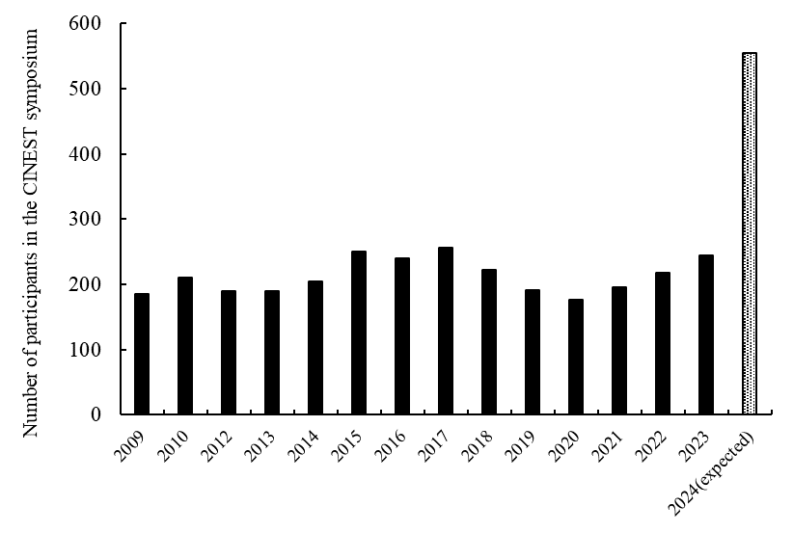
Fig. 1 Figure headings are also printed in Times New Roman 9. (The lay-out of the figures is left to the discretion of the authors.)

The References should be cited in the body text by the author and the publishing date. In the text, the references should be cited in the author-year format, e.g., (Author, 1986), (Author 1 and Author 2, 1997), (Author 1 et al., 2003), (Author 1, 2006; Author 2, 2010), (Author, 2003a; 2003b; 2010). The list of references should be placed at the end of the manuscript in the alphabetical order.

ACKNOWLEDGEMENTS
Important: We will appreciate it if you provide us with an electronic copy of your paper.

REFERENCES
Another, P.K., Friend, A.G., and Third, B.J., The irregularities of prose in first-grade scientific publications, Int. J. of This & That, 10(5), pp.434-441 (1993).
Somebody, A.J., The Manual of Style and Substance, Joe & Sons, New York (1990).

The length of full paper and extended abstract are less than 6 pages and 4 pages respectively, including all figures, tables, and photos. All the manuscript will be printed in black and white.

Top and left margin are 25 mm and Bottom and right margin are 20 mm, respectively. Width of the space between the two columns is 8.0-8.5 mm.

